**IAM Assignment 30th OCT'22**

**Name: Swapnali Thakur**

**Email : swapnalithakur217@gmail.com**

**Assignment 1:- Create an IAM user with username of your own wish and grant administrator policy**

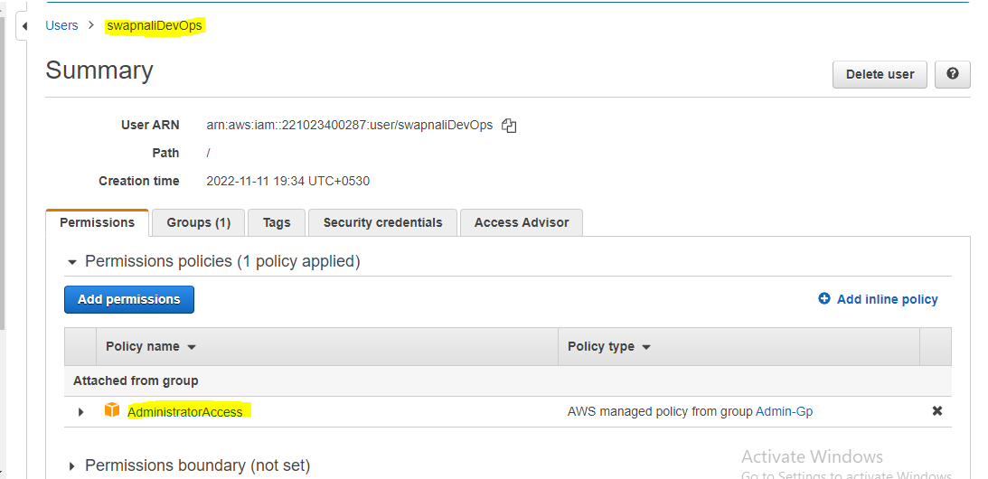

**Assignment 2:- Hello students, in this assignment you need to prepare a developers team of avengers.- Create 3 IAM users of avengers and assign them in developer’s groups with IAM policy.**

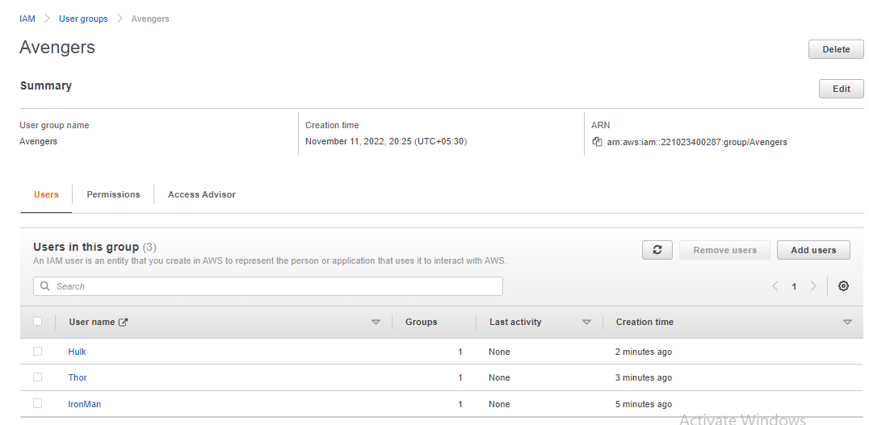

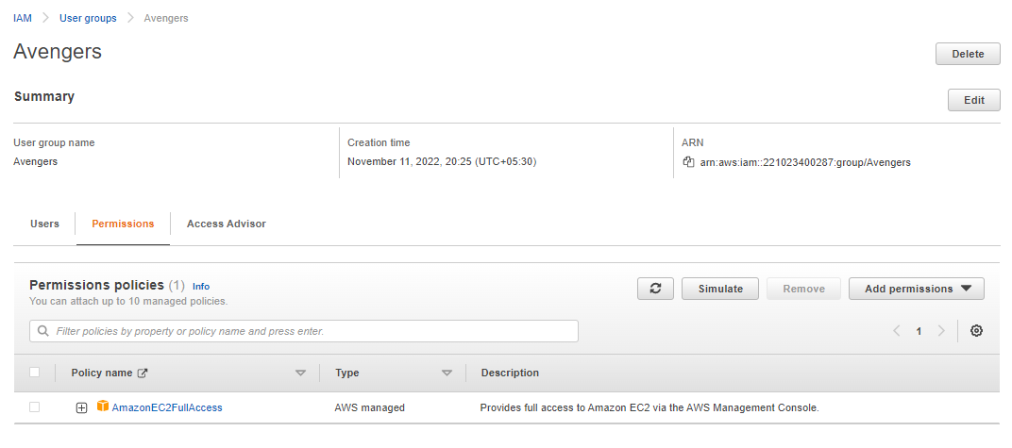

Assignment 3:- Define a condition in policy for expiration like "DateGreaterThan":{"aws:CurrentTime":"2020-04-01T00:00:00Z"}, "DateLessThan":{"aws:CurrentTime":"2020-06-30T23:59:59Z"}Define the span of 4 months as per your wish

**ANS**:

"DateGreaterThan":{"aws:CurrentTime":"2022-01-01T00:00:00Z"}, "DateLessThan":{"aws:CurrentTime":"2022-04-30T23:59:59Z"}

**Assignment 3:- Prepare 15 authentic MCQ questions related to IAM.**

**1. What’s AWS IAM?**

The IAM’s full form is Identity and access management.

**2. Are root users and IAM users the same?**

No, the root user is also called the master user. The IAM user is subset of the root user.

**3. In the IAM service, can we monitor the IAM user activity?**

Yes, you can monitor the actives of IAM users. If any violation, you can remove access for the IAM user

**4. How authentication is controlled in the IAM service?**

* You can mange the users. You can control access keys, passwords, multifactor authentication.
* Manages federated users

**5. What is federated user access management?**

* A user who is allowed to access AWS resources from third-party vendors – such as Google, Facebook, Linked In, Corporate credentials, etc

**6. What is Authorization in terms of AWS IAM service?**

* It’s to provide authorization for certain AWS resources – not all. Example read-only access to the ‘S3’ service

**7. How to control Authorization in AWS IAM?**

* You can control authorization by creating policies.

**9. What’s the other name of the IAM user?**

You can also be called an IAM entity.

**11. What are the 5 top security credentials in AWS IAM?**

* User-id and Password
* E-mail address and Password
* Access Keyes
* Key pair
* Multi-factor authentication

**12. What are AWS IAM roles?**

User – Specific IAM entity

Group – These people will have the same kind of Access

**13. What is the IAM Hierarchy of Privileges?**

* Root user
* IAM user
* user with temporary credentials

**14. AWS evaluates _______ when an IAM principal makes a request.**

ANS: Security Policies

**15. Names of IAM identities (users, roles, and groups):**

|  |  |
| --- | --- |
| (a) | Must be unique within the AWS account |
| (b) | Must be unique within the availability zone |
| (c) | Must be unique within the region |
| (d) | Must be unique within the AWS cloud whole |

**Assignment 4:- Launch your linux instance in IAM and update your machine.**

Created EC2 instance with Amazon linux AMI, t2.micro instance type and key pair

Then connect to My instance using the browser-based client from the Amazon EC2 console :

* In the navigation pane, choose **Instances**.
* Select the instance and choose **Connect**.
* Choose **EC2 Instance Connect**.

After connecting EC2 machine executed **sudo –s** command for root and then **execute yum update** command.

